***Watch Group for Prevention of***

***Teen Drug Dependency***

Megan Meyers

Director

1122 Armitage Dr.

Los Angeles, CA 90202

November 27, 2017

Mr. Alex Johnson

President

Los Angeles County Board of Education

9300 Imperial Highway

Downey, CA 90242

Dear Mr. Johnson:

Enclosed is our proposal to reduce the epidemic of adolescent opioid drug abuse and dependency in Los Angeles County through programs implemented at the middle school level.

As you and the board are aware, the problem of teen opioid drug use is at a crisis point, and interventions are urgently needed to curb the problem. Our watch group prepared two approaches for your consideration that we are confident can have substantial impact on reducing drug use with minimum expenditures.

Please review the enclosed proposal at your earliest convenience. Any questions or concerns may be addressed to me, and you may reach me any time at 323-555-1111. I look forward to working with you on this important matter.

Sincerely,

Megan Meyers

Megan Meyers

Enclosure: Proposal

cc: Los Angeles County Board of Education Member

***Watch Group for Prevention of***

***Teen Drug Dependency***

PROPOSAL FOR REDUCING TEEN DRUG ABUSE AND

DEPENDENCY IN LOS ANGELES COUNTY MIDDLE SCHOOLS

Prepared by Megan Meyers

Director of Watch Group for Prevention of Teen Drug Dependency

Report Distributed November 27, 2017

Prepared for

The Los Angeles County Board of Education

**Abstract**

This report examines the adolescent opioid abuse and dependency epidemic in Los Angeles County, and proposes two cost-effective solutions for interventions at the middle school level. As the opioid crisis continues to worsen for adults throughout the United States, statistics show that the problem is also increasing among teenagers, an especially vulnerable population. First time use of prescription opiates is happening as early as ages 10-12 and is proven to be a precursor to heroin use just 4-6 years later. More 15-19-year-olds are dying from heroin overdose than ever, and the numbers are continuing to rise at an alarming rate. Adolescents engaging in drug abuse are vulnerable to educational deficiencies that will plague them later in life. It is crucial to intervene against this destructive behavior at the time that it is known to begin, in middle school during grades 6-9. Two strategies known to be effective in combating drug abuse for several reasons include informal, non-competitive athletics and focused cognitive training for enhancement of emotional and social skills. This proposal illustrates how both strategies can be implemented for under $2000 with an expected 66% or greater decrease in drug use during and after the programs. Watch Group for Prevention of Teen Drug Dependency recommends the Los Angeles County Board of Education consider the problem of teen prescription drug abuse an urgent one, and implement our recommendations immediately.

**TABLE OF CONTENTS**

ABSTRACT…………………………………………………………………………….. iii

TABLE OF CONTENTS……………….………………………………………………. iv

EXECUTIVE SUMMARY……………………………………………………………… 1

INTRODUCTION……………………………………………………………………….. 2

BACKGROUND………………………………………………………………………… 2

PROPOSAL……………………………………………………………………………… 4

RECOMMENDATIONS………………………………………………………………… 6

CONCLUSION………………………………………………………………………….. 6

WORKS CITED…………………………………………………………………………. 7

BIBLIOGRAPHY………………………………………………………………………. 9

**Executive Summary**

The opioid crisis in America is affecting teenagers everywhere, and Los Angeles County is no exception. Prescription drug use is starting as early as age 10 with children accessing dangerous drugs from their home medicine cabinets. Parents and schools are failing to educate their youth on the dangers of opioids, and thus the adolescents believe they are safe. However, the truth is that nonmedical prescription opioid abuse is a detriment to both cognitive and physical functioning, as well as a strong precursor to heroin use later in life.

An adolescent’s job is to go to school and get the best education possible, hopefully allowing them to enter a good college and become a successful member of society. However, if they are disadvantaged or even side-lined by drug abuse, that can impact their entire lives in irreversibly negative ways. What is worse is the possibility they may get addicted to opioids and proceed to heroin use. Teenagers are dying of heroin abuse at higher rates than ever before.

Watch Group for Prevention of Teen Drug Dependency has developed two proven strategies for prevention of opioid drug abuse at the middle school level, in grades 6-9. They are both extremely cost-effective and easy to implement, yet they are both backed by solid statistical evidence of success. The first proposal is the Botvin’s LifeSkills Training classes. These classes should be implemented within the regular curriculum, starting in 6th grade, and be mandatory for every child.

The second proposal involves mandatory training for every teacher and counselor in the Los Angeles County School District for identifying at-risk or currently using teens. These teens would be referred to a new afterschool sports program where they would get exercise, social support, and further monitoring, all proven interventions to reduce drug abuse.

Watch Group for Prevention of Teen Drug Dependency is urging the Los Angeles County Board of Education to consider this problem a crucial one, and take immediate actions based upon our recommendations. We believe these strategies can be implemented for under $2000, yet will yield a 66% or better decline in drug use.

**Introduction**

Los Angeles County is facing a crisis among its adolescents in the form of rising prescription drug abuse, specifically opioids like Vicodin (hydrocodone), OxyContin (oxycodone) and others. According to the Youth Risk Behavior Survey of Student Population from data provided by the Substance Abuse and Mental Health Services Administration, lifetime prescription drug use among teens has increased since 2012 (Figure 1), while alcohol and marijuana use trended down and stayed the same, respectively (Dew). This is a worrisome shift in behavior, especially considering the opioid drug abuse epidemic across the US affecting all races, ages, and socio-economic classes that is making it easier than ever for a young adult to access potentially dangerous drugs right from the home (“US Dept. of Defense). Additionally, the youth population has special vulnerabilities that may leave them with lifetime difficulties and disadvantages, different from their adult counterparts. It is imperative that we target this population specifically with a tailored approach to fit their needs, and intervene against this problem at the time it will do the most good.

Adolescents spend a great deal of time in school, and this environment provides a good opportunity for prevention and intervention. I am proposing two ways we can reduce drug use at the middle school level (grades 6-9) - a life skills training class for every student, and an afterschool sports program specifically aimed at students meeting the at-risk criteria, as identified by their teachers and counselors. These are both budget-friendly and shown to be effective by numerous studies.

**Background**

In the United States, drug overdose is the leading cause of accidental death since 2015. Among 12 and 13-year-olds, the most frequently abused substances are prescription drugs, and the top source of their acquisition is the family medicine cabinet (“US Dept. of Defense”). Teenagers are more vulnerable than adults to accidental deaths and complications resulting from prescription opioid pain medications largely due to the misperception that the drugs are safe. Furthermore, parents discussing drug and alcohol abuse with their children are often leaving out the risks and dangers of abusing prescription medication (Tormoehlen et al. 493), leaving the adolescents erroneously believing the drugs to be benign as compared to the illicit drugs with whose consequences they are more familiar. Compounding this issue is the widespread availability of the drugs for all Americans, as studies show that as adult prescriptions for opioids increase, so do poison control center calls regarding adolescent use (Sheridan 487).

Opioids are known to cause cognitive defects in attention and memory, and the more they are abused, the worse these defects become. Evidence of general intellectual decline for the duration of use has been seen in some studies. Even mild withdrawal from opioids include cognitive problems for weeks plus additional flu-like symptoms and bodily discomfort for up to 3 days (Rapeli et al. 2). Adolescents who are attending school and acquiring a foundational education for their futures cannot afford to have recurring issues with their minds and bodies. Therefore, abuse of prescription drugs at this level can include the added problems missed classes, lower grades, and gaps in education that can affect them later in life. With college more important than ever to a good life in America, teenagers whose minds and bodies are at a disadvantage due to drugs or withdrawal symptoms may not be able to compete with grades or extracurriculars to get admissi

on to a good university. Some teens may lose their opportunity for college altogether if they are prosecuted for drug offenses and lose their financial aid (Federal Student Aid). Prevention of prescription drug use at an early age can potentially eliminate these problems, and help teens to stay on the right track for success.

Prescription opioid abuse is considered the number one gateway to heroin addiction, meaning that these young adults are at an increased risk of serious problems associated with drug use and addiction that could impact their entire lives in myriad ways (“US Dept. of Defense”). The chemical composition of prescription opioids is very similar to that of heroin and thus, the effects are similar. Studies show that adolescents who abused prescription opioids in the past are up to 13 times more likely to initiate heroin use with 45% of those initiations occurring between the ages of 16-18. Those with the highest risk of abusing heroin were those who started the abuse of prescription drugs between the ages of 10-12 (Cerdá et al. 609). A federal report released this year by the CDC illustrates the extreme danger to youth in America from heroin addiction. The death rate has been rising steadily since 2005, and as of 2015, heroin is the deadliest drug in the opioid family for teenagers ages 15-19. The percentage of deaths from heroin has tripled in the five-year span from 2010 to 2015 (Hedegaard 6).

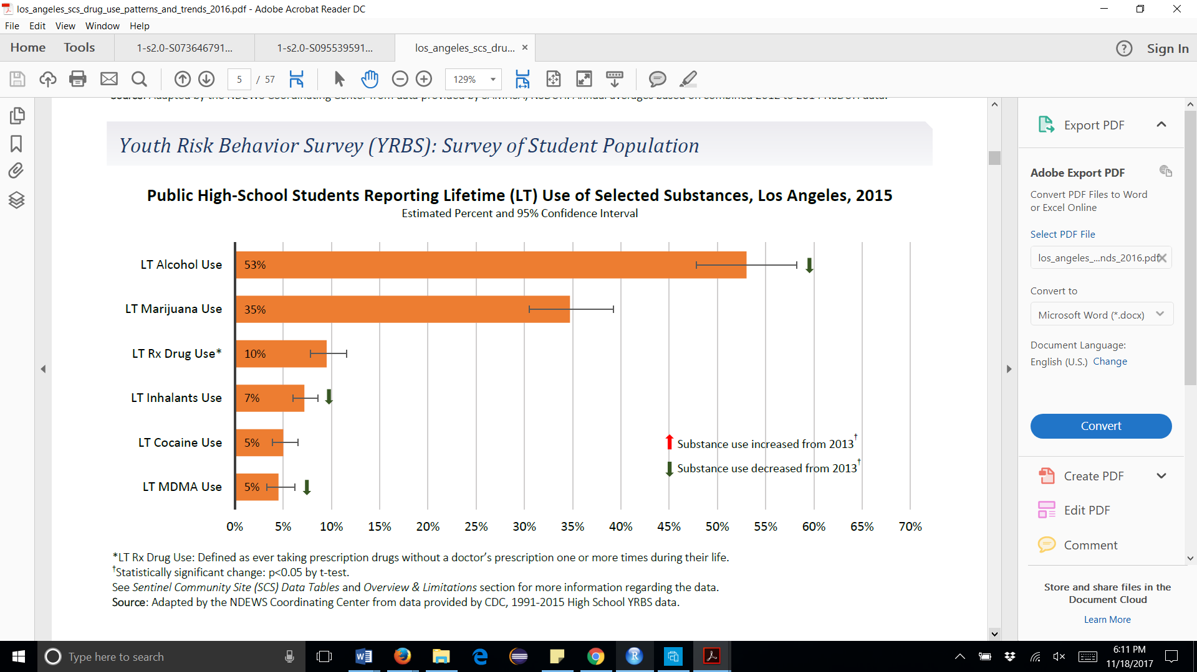

*Figure 1.* Source: Dew

**Proposal**

*Afterschool sports program*

Several studies have shown that children who participate in sports and/or physical exercise on a regular basis are at decreased risk for prescription opioid abuse. Although there was some concern in the past that injuries sustained during physical activity would introduce opioids into a young person’s life, the opposite is shown to be true. It is believed that the positive social connections and natural endorphin elevation obtained by routine physical activity help to combat the trend to take up prescription misuse, especially for use initiated for mental health reasons (Knopf 6-7). Major depressive incidents in a young adult’s life are a common trigger to begin self-medicating with prescription opioids. Physical activity is also proven to ward off mental health imbalances and contribute to mood stability (Bardo and Compton 3). Additionally, some small-scale studies provide evidence that exercise can improve outcomes for individuals already dealing with substance abuse issues (Bardo and Compton 6).

Teachers and counselors can be taught to look for the risk-factors and signs associated with substance abuse or impending potential abuse. Once identified, an at-risk child can be invited to participate in an afterschool program that will focus on physical activity and informal sports. This program will be led by 2-3 teachers, counselors, parents, or volunteers, and will focus the children’s attention on fun physical games for 90 minutes, three times per week. The program will run in the gym and/or the athletic field and will rotate various activities such as softball, touch football, basketball, volleyball, dancing, dodgeball, and any other activities deemed fun and appropriate by the leaders and students. The focus of this program is not competition or athleticism, but fun, socialization, and collaborative effort with the added benefit of adult monitoring for the specific concerns surrounding their drug use risks.

Cost of the afterschool program will be minimal. The program will take place during times that the school is already open, and I anticipate the ability to ask teachers, counselors, and parents to volunteer their time on a rotating basis without objection. Balls and other equipment are already owned by the school, but more can be provided via a small fundraiser I will organize if needed. There will be a one-time class for all teachers and counselors at the school, as well as the additional volunteers who will help lead the activities, to educate them on the risk factors to look for and the appropriate ways to interact with these children. All teachers and counselors will be required to take the class to educate them on which students to refer to the afterschool program. The class will need to be offered approximately 4 times to meet the various scheduling requirements of those involved. A cost of $250 per class is anticipated to have an expert spend 60-90 minutes lecturing making the total cost of this program about $750.

*LifeSkills Training Classes*

Gilbert Botvin’s LifeSkills Training (LST) program, a science-based approach to drug and alcohol prevention, is proven by many studies to be effective at reducing drug use among adolescents for up to 6 years after the class (Gorman 22). The training includes more than teaching children the dangers of drug use. It teaches them the skills and coping mechanisms they need to resist peer-pressure and deal with their emotions without reaching for assistance from illicit substances. They learn drug resistance skills, personal self-management skills, and general social skills to help them develop self-confidence and self-esteem, which allow them to recognize their voices and that they can make positive choices for themselves (EPiSCenter).

LifeSkills Training has a class specifically designed for implementation at the middle school level. It has been shown, in addition to reducing opioid and prescription drug abuse, to have the following outcomes (Figure 2):

* Cut tobacco use of 87%
* Cut alcohol use by 60%
* Cut polydrug use by 66%
* Reduces violence, risky driving behavior, and risky sexual behavior

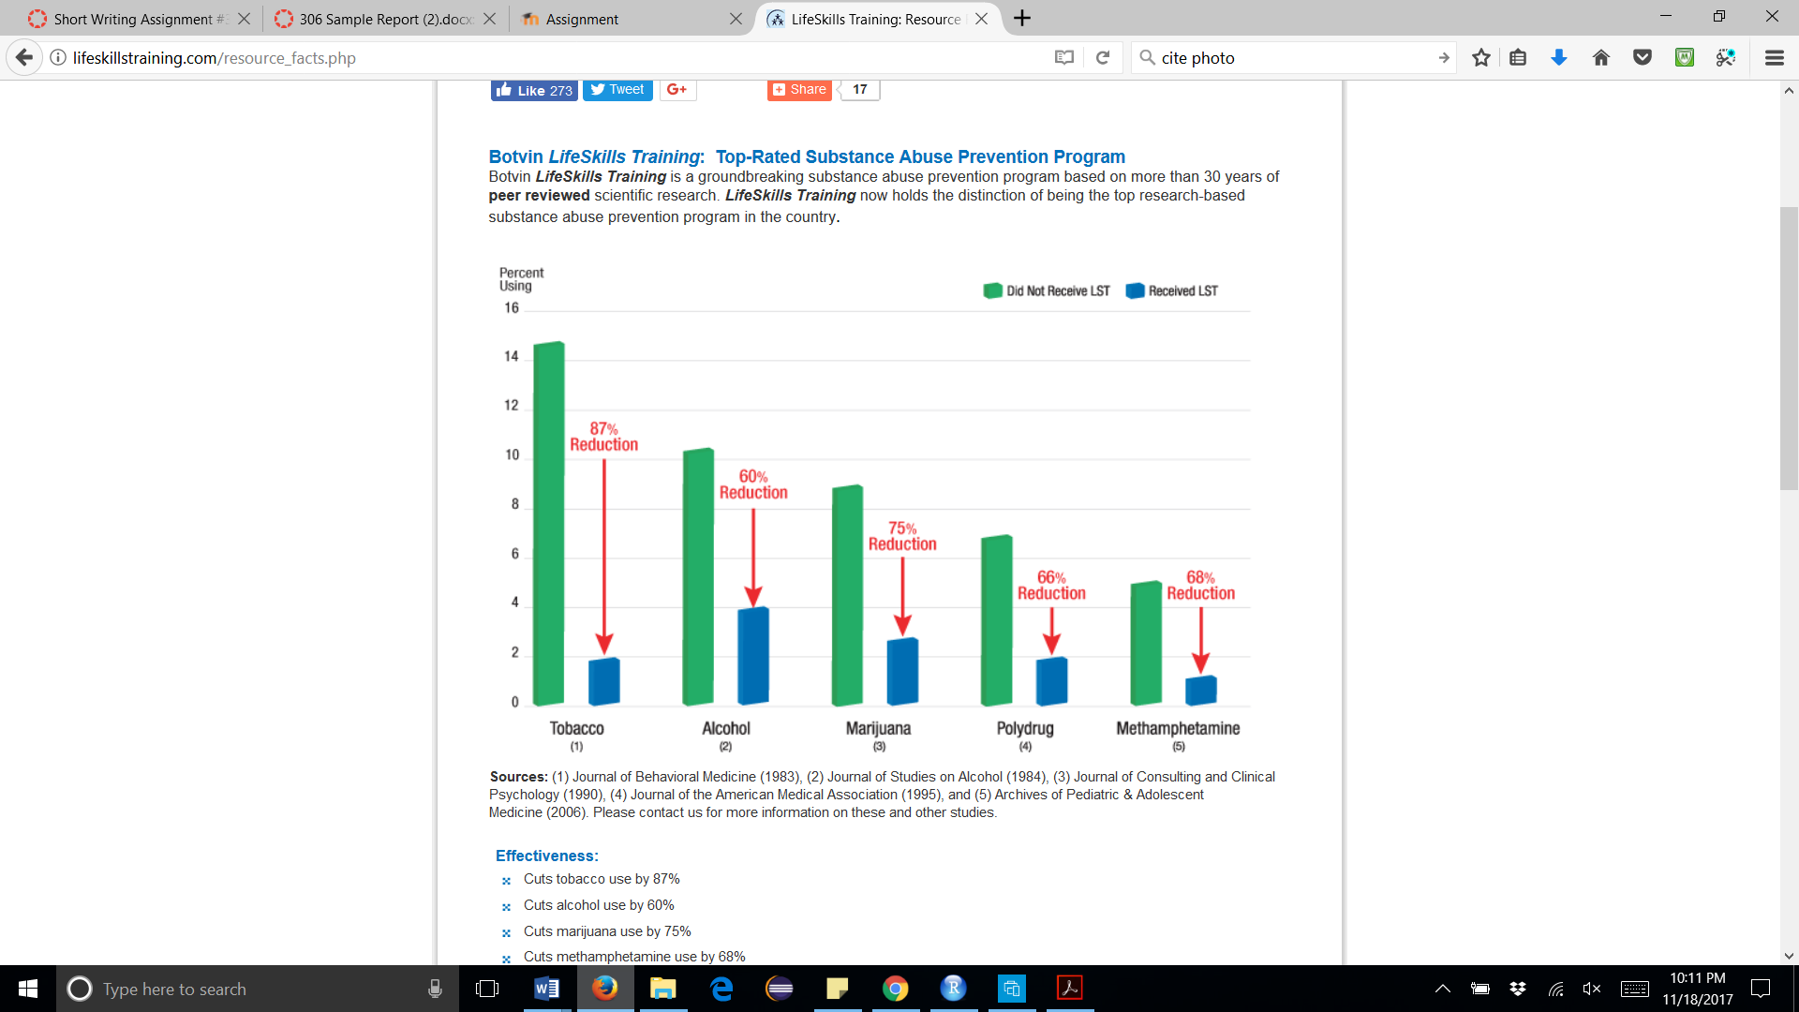

*Figure 2.* Source: Botvin’s LifeSkills Training

The cost of LST is $200/teacher for an unlimited number of students. The 35-50-minute modules are perfect for integrating into a school period 1-3 times/per week, allowing every student to participate in the training as a part of a normal day (Botvin’s LifeSkills Training). To have every student at the school participate will require 4 teachers for a total cost of $800. I recommend implementing the class twice a week, during the free study period. This will eliminate impact on the normal curriculum.

**Recommendations**

In continued efforts to reduce the opioid crisis among adolescents in Los Angeles County, Watch Group for Prevention of Teen Drug Dependency is urging the Los Angeles Board of Education to take the following actions:

* Mandatory LifeSkills Training classes for all middle school youth in grades 6-9 occurring during the normal school day as part of the regular curriculum.
* Proper training for all teachers and counselors at every middle school in Los Angeles County to identify at-risk youth or youth that may be already abusing drugs.
* An afterschool informal sports program for the youth identified above, led by those same trained teachers and counselors, or any parents and/or volunteers who undergo training.
* A written and agreed upon strategy including specific goals and target dates to achieve them to monitor the progress of the proposals herein, and to document the Board’s efforts to protect the children in its care.

These actions should be considered urgently needed considering the information and statistics supplied in this proposal.

**Conclusion**

The opioid drug problem in America is continuing to worsen, and our children are caught up in the epidemic. They face special risks and may be hurt by drugs and addiction more so than adults in similar situations. Our adolescents should be concerned with furthering their education, going to college, and developing into well-adjusted adults, ready to participate in society as fully-functional members. It is imperative that we begin interceding on their behalf against substance abuse at the middle school level, when they are most vulnerable to harm from drugs, and also most receptive to our prevention strategies.

The two proven and effective strategies proposed here will counter the drug problem from both the physical and mental aspects at the middle school level. The cost of implementing both is negligible, but the pay-off is potentially tremendous. I look forward to discussing further details with you and answering any questions you might have at your earliest convenience. My sincere hope is that after reading this, you are as excited as I am to start furthering our children’s success, and reducing the preventable harm that is prescription opioid drug abuse.

**Works Cited**

Bardo, Michael. T., and Wilson. M. Compton. “Does Physical Activity Protect against Drug Abuse Vulnerability?” Drug and Alcohol Dependence, vol. 153, 2015, p. 3-6.

*Botvin’s LifeSkills Training.* National Health Promotion Associates. [www.lifeskillstraining.com](http://www.lifeskillstraining.com). Accessed 9 November 2017.

Cerdá et al. “Nonmedical Prescription Opioid Use in Childhood and Early Adolescence Predicts Transitions to Heroin Use in Young Adulthood: A National Study.” The Journal of Pediatrics, vol. 167, no. 3, 2015, pp. 605–612.e2.

Dew, Brian J., et al. “Los Angeles County Sentinel Community Site Drug Use Patterns and Trends, 2016.” National Drug Early Warning System Funded at the Center for Substance Abuse Research by the National Institute on Drug Abuse. October 2016. University of Maryland, College Park. [www.ndews.org](http://www.ndews.org). Accessed 17 November 2017.

*EPiSCenter.* Pennsylvania State University and the Pennsylvania Department of Human Services, 2015. <http://www.episcenter.psu.edu/ebp/lifeskills>. Accessed 9 November 2017.

*Federal Student Aid.* Office of the US Department of Education. [www.studentaid.ed.gov/sa/eligibility/criminal-convictions](http://www.studentaid.ed.gov/sa/eligibility/criminal-convictions). Accessed 17 November 2017.

Gorman, Dennis M. “The “Science” of Drug and Alcohol Prevention: the Case of the Randomized Trial of the Life Skills Training Program.” International Journal of Drug Policy, vol. 13, no. 1, 2002, pp. 21–26.

Hedegaard, Holly et al. “Drug Overdose Deaths in the United States, 1999-2015.” Centers for Disease Control and Prevention National Center for Health Statistics Data Brief. no. 217, February 2017.

Knopf, Alison. “Participation in Sports Reduces Risk of Teen Rx Opioid Abuse.” Alcoholism and Drug Abuse Weekly, vol. 28, no. 33, 2016, pp. 6–7.

Rapeli, Pekka, et al. “Cognitive Function during Early Abstinence from Opioid Dependence: a Comparison to Age, Gender, and Verbal Intelligence Matched Controls.” Vol. 6, 2006, pp. 2006, Vol.6.

Sheridan, et al. “Association of Overall Opioid Prescriptions on Adolescent Opioid Abuse.” Journal of Emergency Medicine, vol. 51, no. 5, 2016, pp. 485–490.

Tormoehlen, Laura M., James B. Mowry, Jeffrey D. Bodle & Daniel E. Rusyniak (2011) “Increased adolescent opioid use and complications reported to a poison control center following the 2000 JCAHO pain initiative”, Clinical Toxicology, 49:6, 492-498, DOI: 10.3109/15563650.2011.587819

"US Department of Defense to Study Impact of Dispensing Opioids in Locking Vials; Federal Funding Available for States to Study Effect on Preventing Teen Drug Abuse & Opioid Addiction." *Politics & Government Business*, 19 Jan. 2017, p. 28.

**Bibliography**

Bardo, Michael. T., and Wilson. M. Compton. “Does Physical Activity Protect against Drug Abuse Vulnerability?” Drug and Alcohol Dependence, vol. 153, 2015, p. 3-6.

*Botvin’s LifeSkills Training.* National Health Promotion Associates. [www.lifeskillstraining.com](http://www.lifeskillstraining.com). Accessed 9 November 2017.

Cerdá et al. “Nonmedical Prescription Opioid Use in Childhood and Early Adolescence Predicts Transitions to Heroin Use in Young Adulthood: A National Study.” The Journal of Pediatrics, vol. 167, no. 3, 2015, pp. 605–612.e2.

Dew, Brian J., et al. “Los Angeles County Sentinel Community Site Drug Use Patterns and Trends, 2016.” National Drug Early Warning System Funded at the Center for Substance Abuse Research by the National Institute on Drug Abuse. October 2016. University of Maryland, College Park. [www.ndews.org](http://www.ndews.org). Accessed 17 November 2017.

*EPiSCenter.* Pennsylvania State University and the Pennsylvania Department of Human Services, 2015. <http://www.episcenter.psu.edu/ebp/lifeskills>. Accessed 9 November 2017.

*Federal Student Aid.* Office of the US Department of Education. [www.studentaid.ed.gov/sa/eligibility/criminal-convictions](http://www.studentaid.ed.gov/sa/eligibility/criminal-convictions). Accessed 17 November 2017.

Gorman, Dennis M. “The “Science” of Drug and Alcohol Prevention: the Case of the Randomized Trial of the Life Skills Training Program.” International Journal of Drug Policy, vol. 13, no. 1, 2002, pp. 21–26.

Hedegaard, Holly et al. “Drug Overdose Deaths in the United States, 1999-2015.” Centers for Disease Control and Prevention National Center for Health Statistics Data Brief. no. 217, February 2017. [www.cdc.gov/nchs/data/databriefs/db273.pdf](http://www.cdc.gov/nchs/data/databriefs/db273.pdf).

Knopf, Alison. “Participation in Sports Reduces Risk of Teen Rx Opioid Abuse.” Alcoholism and Drug Abuse Weekly, vol. 28, no. 33, 2016, pp. 6–7.

Rapeli, Pekka, et al. “Cognitive Function during Early Abstinence from Opioid Dependence: a Comparison to Age, Gender, and Verbal Intelligence Matched Controls.” Vol. 6, 2006, pp. 2006, Vol.6.

Sheridan, et al. “Association of Overall Opioid Prescriptions on Adolescent Opioid Abuse.” Journal of Emergency Medicine, vol. 51, no. 5, 2016, pp. 485–490.

Tormoehlen, Laura M., James B. Mowry, Jeffrey D. Bodle & Daniel E. Rusyniak (2011) “Increased adolescent opioid use and complications reported to a poison control center following the 2000 JCAHO pain initiative”, Clinical Toxicology, 49:6, 492-498, DOI: 10.3109/15563650.2011.587819

"US Department of Defense to Study Impact of Dispensing Opioids in Locking Vials; Federal Funding Available for States to Study Effect on Preventing Teen Drug Abuse & Opioid Addiction." *Politics & Government Business*, 19 Jan. 2017, p. 28. *General OneFile*, libproxy.csun.edu/go.galegroup.com/ps/i.do?p=ITOF&sw=w&u=csunorthridge&v=2.1&id=GALE%7CA477581531&it=r&asid=1dd8446b70ce2165246b07dd70461cf2. Accessed 30 Oct. 2017.